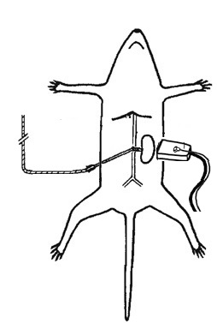

**Transducer Left Kidney**

**Microbubble Infusion**